Information content of the Russian services surveys
Tamara Lipkind, Liudmila Kitrar, Georgy Ostapkovich

Abstract
The paper explores information content of the Russian services surveys using the regular BTS results since 2012Q1 to 2017Q4. To summarise perceptions and expectations in a one-dimensional index and analyse economic development in the sector, the confidence and business climate indicators are calculated. Within a VAR framework, the reaction of value added in services and GDP to shocks in business climate indicator was examined.
The survey results provide reliable information on economic sentiment and business climate that is essential to measure recession and recovery development of the sector. Since 2013, the survey’s results demonstrate a stable trend of "pessimism accumulation" in the main indicators dynamics. Aggregate entrepreneurial assessments reflect the weak and volatile demand for services, the deterioration in production and financial performance of service organizations and the unfavorable business climate in this sector. The protracted decline in the households’ real disposable incomes and weak consumer activity are the main factors of the services confidence flat path in 2017.

Keywords: services surveys, confidence indicator, business climate indicator, Russia

JEL classification: C81, C82, L89
Introduction
Over the past 15 years, the Russian services sector demonstrates the most intensive growth of the gross value added (GVA) in Russia [Kitrar and Upadhyaya, 2017]; it was a driver of the GDP sustainable growth (excepting the periods of cyclical recession). The services contribution to the national economy increases, and by 2010, it had reached about a half of GVA. It resulted in the premature de-industrialization at the background of rather low and unstable incomes of economic agents, especially among non-resource-based exporters and households.
The protracted nature of such development and the lack of adequate structural reforms that could encourage a sustainable intensive growth, help to surmount the series of recurring crises and stagnations, to break the country's dependence on commodity prices – all these factors have become crucial for the Russian economy, especially since 2012. In our opinion, large-scale early de-industrialization coupled with the absence of noticeable sectoral structural changes hinder the economy from overcoming inefficient allocation of production factors, presence of non-competitive markets, innovations shortage, corruption, and strong dependence on the world commodity markets [Upadhyaya et al, 2016].
Despite the services became a dominant sector of the Russian economy, there was a lack of the essential statistical information on its development, including early response indicators, performance indicators, and information on sectoral limitations. Additionally, traditional hard statistics often revised, especially when the national economic classifications were changed.
The current official economic dynamics is not sufficient for a cyclical analysis and short-term forecasting; it became especially clear during the deep recession of 2008-2009. The limited availability of reliable information on economic sentiment to measure recessionary events was a strong incentive to start conducting business tendency surveys (BTS) of services, both to analyze the sector development and to construct an integrated indicator able to evaluate the overall economic dynamics. The pilot survey was carried out in 2009-2010, and then included in the Russian Program of business tendency surveys (BTS) in 2012.
The survey is conducted by the Higher School of Economics (HSE) in collaboration with the Federal State Statistics Service (Rosstat). The HSE area of responsibility covers methodology development, data treatment (seasonal adjustment, calculation of composite indicators), preparing analytical reviews, scientific research and publications. Rosstat is responsible for sampling and collecting information. The survey program was adapted to national specificities but is based on the European standards; therefore, it is considered as harmonised with the EU Programme of Business and Consumer Surveys.
Data description and methodology
The study is based on the result of regular Russian services BTS for the period since 2012Q1 to 2017Q4. Therefore, we have quite long series for the seasonal adjacent and economic analysis, but it is not sufficient to identify their cyclical profile.
The survey is carried out quarterly, covers about 5 500 organizations providing commercial services (except micro organizations), and includes 15 kinds of economic activities according to the Russian Classification of Economic Activities (OKVED), which is compatible with the Statistical Classification of Economic Activities in the European Communities (NACE Rev. 1.1). The survey questionnaire and the list of surveyed economic activities are shown in Appendix.
Multivariate stratified sampling with random or mechanical selection of observation units in stratum is used; the fixed panel of companies is updated at regular intervals. Stratification is required due to the structural heterogeneity of the Russian economy; stratification criteria are kinds of activity, firm size (the number of employees) and regions. Target universe is obtained from the Statistical Business Register; the sample is representative at the level of aggregate economic activities and regions.
The average response rate is larger than 90% because to participate in statistical surveys in Russia is compulsory and non-response is not a considerable problem.
To eliminate seasonal pattern in time series of balances, the seasonal decomposition procedure is applied; we use SPSS software with the Autoregressive Integrated Moving Average (ARIMA) module.
To summarize perceptions and expectations in a one-dimensional sectoral index, we calculate the services confidence indicators in accordance with the OECD and European Commission recommendations [European Commission, 2017; OECD, 2003] as the simple arithmetic average of the seasonal adjusted balances (in percentage points) of the assessments:
- Business situation changes over the past 3 months;
- Demand for services changes over the past quarter;
- Demand for services expectations over the next 3 months.
To extract the information common for a set of survey series that is supposed to move contemporaneously with overall sectoral activity, we construct the business climate indicator (BCI) according to the factor analyses fundamentals (principal component method). The algorithm is harmonised with European recommendations [European Commission, 2017a, 2016, 2000]; the input series set includes five balances (seasonal adjusted):
- Business situation changes over the past quarter;
- Demand for services changes over the past quarter;
- Demand for services expectations over the next quarter;
- Firm’s total employment changes over the past quarter;
- Firm’s total employment expectations over the next quarter.
To examine in more detail the relationship between services BCI and reference series, namely, GDP and services GVA, we used the standard bivariate Vector Autoregression Model (VAR); the time series are tested preliminarily for stationarity by the Augmented Dickey-Fuller (ADF) test. The VAR results were interpreted using the impulse response function (IRF).
Results
Consider the basic information capabilities of the services BTS according the results accumulated by the end of 2017.
Recent development in the Russian service sector
The survey’s results show a stable five-year trend of "pessimism accumulation" in the main indicators dynamics since 2013. They reflect the weak and volatile demand for services, the deterioration in production and financial performance of service organizations and, generally speaking, the unfavorable business climate in this sector of the economy. The Russian service market continues to function under conditions of stagnant economy.
The movement of the main composite indicator of the survey – a seasonally adjusted confidence indicator – is clearly downward, with a slight improvement in early 2016. The subsequent increase in entrepreneurial optimism did not result in moving confidence to a positive zone. The indicator values in 2017 are consistently below zero at 4 percentage points (see Fig. 1).
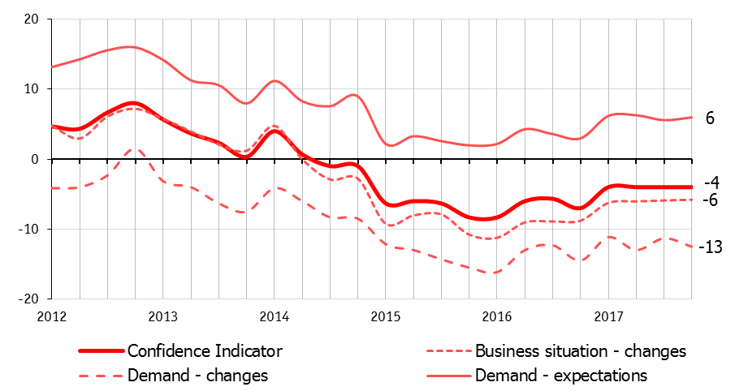
Fig. 1. Services confidence indicator and its components for the period 2012 Q1–2017 Q4; balances, %
Optimistic sentiment sonly in the insurance segment, where the indicator reached a positive value. The most unfavorable business climate is observed in the real estate activity, the personal services, and the repair of personal goods (see Fig. 2).
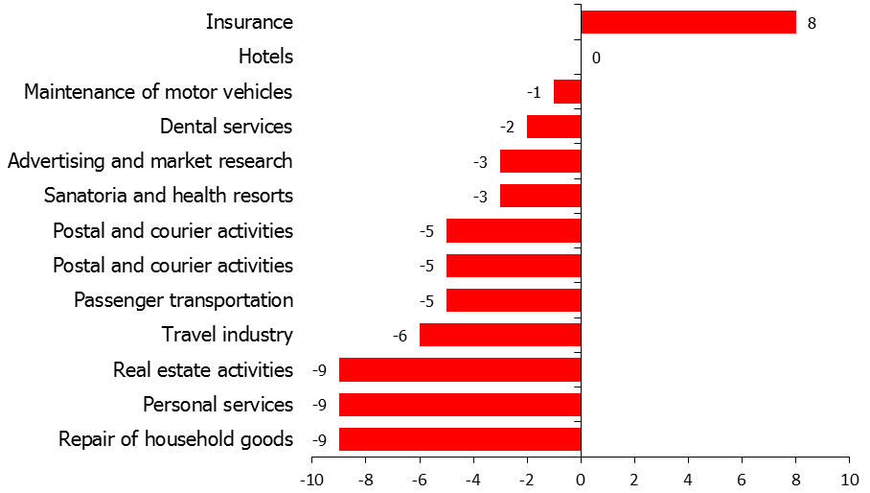
Fig. 2. Services confidence indicator in various kinds of services activities, 2017 Q4; balances, %
During 2017, the short-term respondents’ expectations suggested that overcoming a prolonged recession for the service sector is possible. However, to implement expectations, at least two conditions must be fulfilled – maintaining macroeconomic stability and recovering consumer demand; the latter, unfortunately, was not met. The survey covers mainly organizations that provide Business-to-Consumer services; therefore, the development of these organizations depends strongly on household incomes. However, in 2017 real disposable incomes of the population continued to fall (amounted to 98.3% against the previous year). Weak consumer activity is the main reason for the flat path of the services confidence in 2017.
The demand for services shows a bumpy movement in the last two years; as a result, in the end of 2017 it only slightly exceeds its value in the crisis epicenter in early 2016. Under weak demand, there is no expansion of the services volume (see Fig. 3).
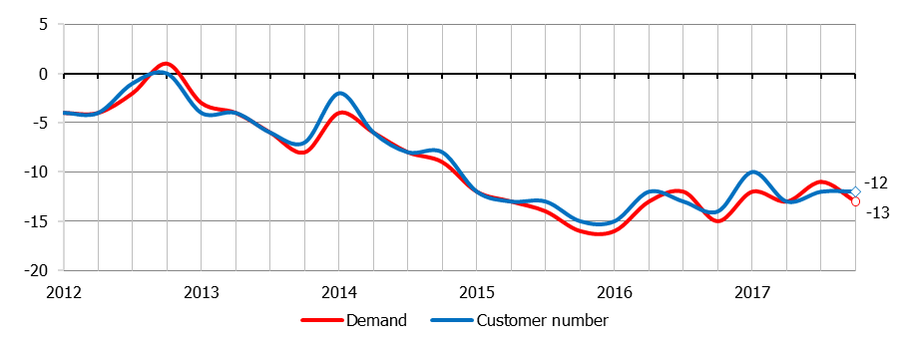
Fig. 3. Past demand for services and the number of customers; 2012 Q1-2017 Q4; balances, %
The demand for almost all observed services decreases, excepting insurance where the balance of the past demand estimates is positive (+2%). On the contrary, the most intense negative trend we can see in advertising and market research as well as in the real estate activity. The clients’ outflow also is observed in all the surveyed activities except insurance; a zero balance of estimates in insurance indicates stability of the services volume.
The shortage of effective demand, according to the entrepreneurial opinions, is a key factor limiting business; 47% of respondents note its negative impact in 2017. In the segments of real estate activity, this problem is highlighted by 66% of entrepreneurs; over the last year, the share of such opinions has increased by 7 points confirming the fall in the real estate market linked to permanent decline in the household incomes.
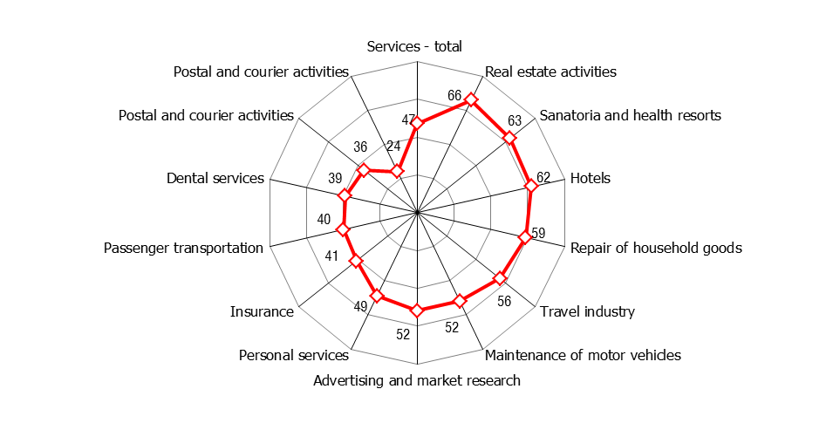
Fig. 4. Limiting factor «insufficient demand; 2017 Q4; %
The employment in services decreases in every quarter of 2017 with the equal intensity; balance of the past employees number assessments maintains the same value of (-7%). The negative employment expectations are noteworthy: the services is the most socially oriented activity among the basic sectors of the Russian economy, providing jobs and incomes for a large part of the population, especially in small cities where there is not enough industrial and construction organizations. See Fig. 5 for the employment past changes and expectations for the next quarter.
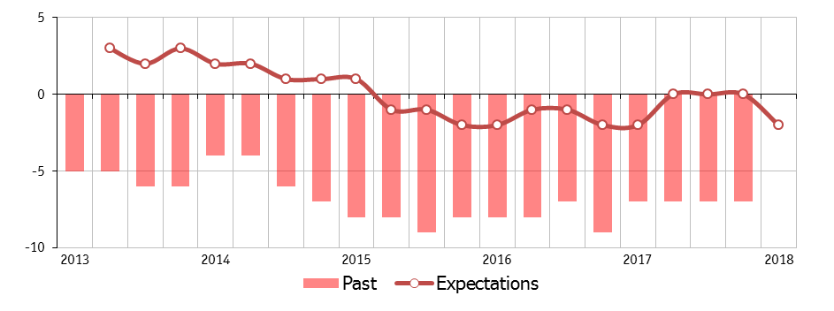
Note: the question about employment was in cluded in the survises survey in 2013.
Fig. 5. Employment; past changes and expectations; balances, %
The results of the latest surveys indicate, on average, selling price stability. At the end of 2017, 83% of respondents noted the unchanged prices, 8% stated their growth and 9% – the decrease; as a result, the balance of assessments was close to the neutral one. The majority of entrepreneurs do not intend to raise prices for services in early 2018; selling price expectations for 2018 Q1 drop to the lowest level for the observation period (Fig. 6).

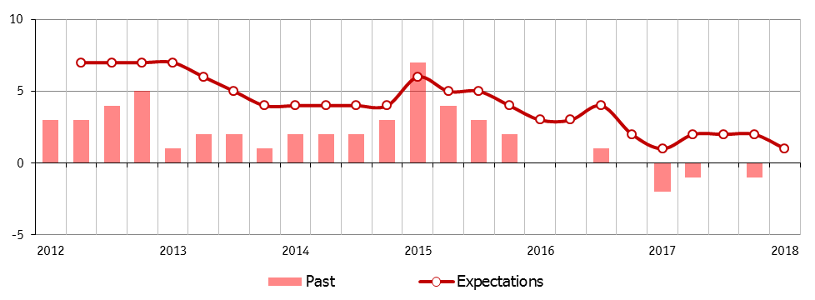
Fig. 6. Selling prices; past changes and expectations; balances, %
A significant number of entrepreneurs considers the current selling prices to be clearly underestimated relative to their "normal" (acceptable for the current business situation) level; among them, in particular, almost half of top managers of passenger transport companies. Thus, the low inflation in services is mainly due to the inability to raise prices in conditions of weak effective demand.
The financial positions of service organizations are getting worse from the beginning of 2017, as the profit dynamics indicates (Fig. 7). By the end of 2017, profit has declined in the all observed activities, the balance of estimates decreased to (-18%). The profit shrank more intensively in advertising and market research, real estate activities and personal services.
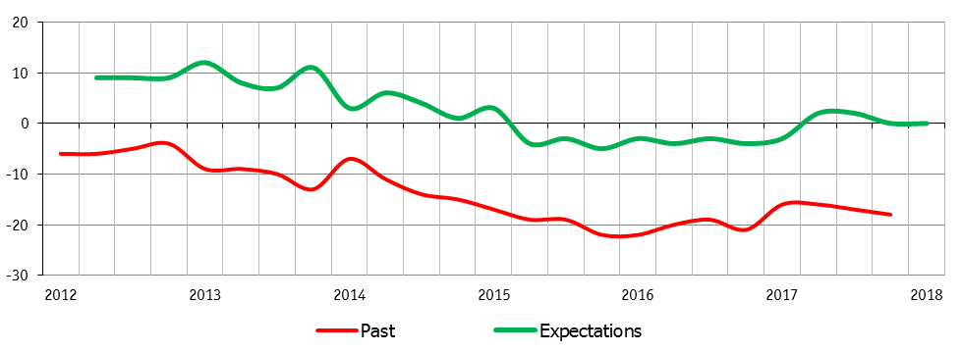
Fig. 7. Profits; past changes and expectations; balances, %
Among the limiting factors, insufficient demand for services exerts the greatest pressure on business as almost half (47%) of respondent consider; although, it is by 5 points lower than in the beginning of 2016 (Fig. 8). The financial constraint and high taxation level are the other two main problems of services organizations.
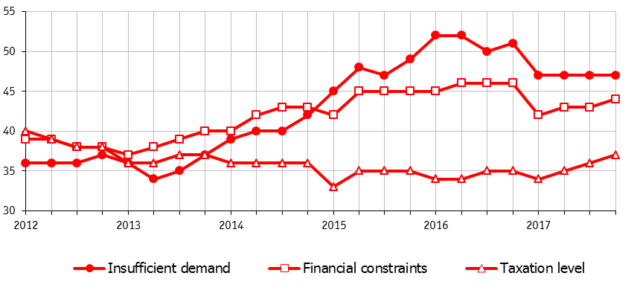
Fig. 8. Main limiting factors, 2012-2017, %
The negative impact of unfair competition and qualified personnel shortage are marked much less often. The most of respondent do not mention a lack of space and/or equipment, inadequate legislation and authorities’ corruption as significant problems (Fig. 9).
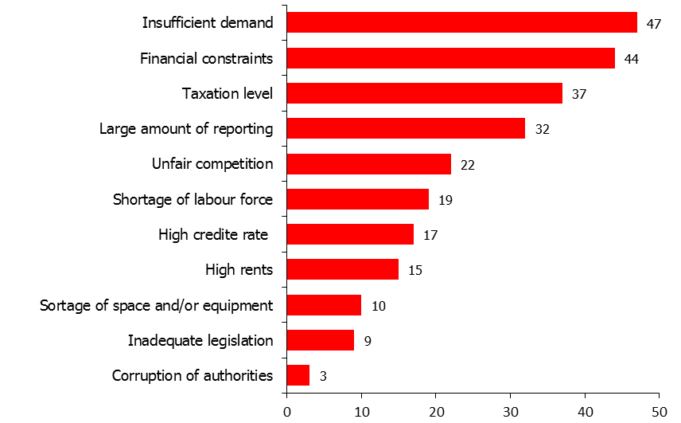
Fig. 9. Limiting factors, 2017 Q4, %
The limiting factor “corruption” is not included in the questionnaires of regular industry, construction and trade BTS due to their harmonization with the European counterparts. However, corruption problem in Russia is of particular interest, so this question is added to the services questionnaire. Aggregate entrepreneurial opinions seem, at first glance, encouraging: this factor is always noted by 3-4% of respondents only. However, these results contradict common sense. Possibly (and very likely), this phenomenon is explained by the fact that some (or many) respondents consider corruption as a traditional and integral part of any businesses; they include corruption costs in production costs and, therefore, do not esteem them as a major problem.
“Pawnshop Indicator”
According to a retrospective of the BTS results, the dynamics of pawnshop activity is almost always in opposition to the dynamics of household incomes (see Fig. 10). Therefore, we could use the so-called “Pawnshop Indicator” (actually, the confidence indicator in this segment) as an auxiliary tool for identifying possible changes in the dynamics of real disposable income of households.
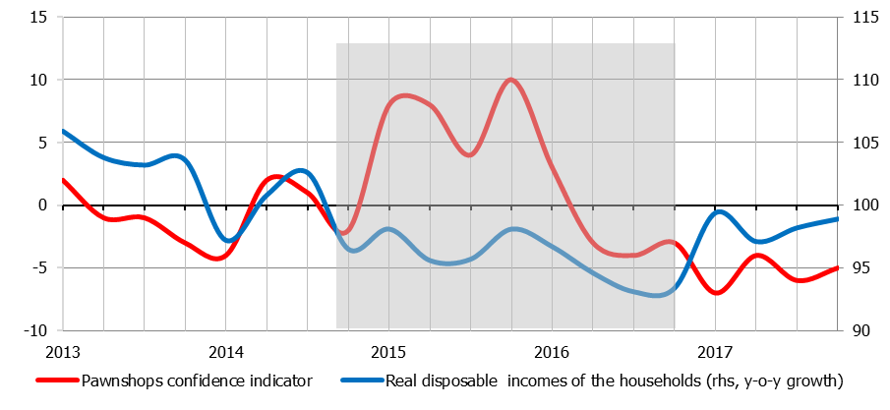
Fig. 10. “Pawnshop Indicator” and real disposable income of households; 2013-2017, %
Pawnshops are the main beneficiaries of the recent crisis, which became an incentive for this business development. The pawnshops allow the population with low income, without a credit history and sureties, to receive cash loans. Despite these loans are of short-term and high interest, they help low-income people to get money for living, and small business owners to get cash for operating expenses. Pawnshops successfully meet these vital needs during crisis periods, and this kind of services activity demonstrates an impressive growth of business confidence while all other observed activities decline.
The rapid growth in the pawnshops segment over the period since the last quarter of 2014 to the middle of 2016 was replaced by decline in 2016-2017. It suggests that the households’ financial situation is gradually improving, and this assumption is confirmed by statistics on the real wages growth in 2017. However, taking into account that real incomes continue to decline, the “Pawnshops Indicators” dynamics likely indicates also that the vast part of the Russian population has adjusted the consumer basket at a lower income level and learned how to survive without pawnshop loans.
Business Climate Indicator in services, its correlation with the services GVA and GDP
…………………………………………………………………………..
Conclusions
The services BTS results provide reliable information on the economic sentiment and business climate that is essential to measure recession and recovery development of the sector.
Since 2013, the survey’s results demonstrate a stable five-year trend of "pessimism accumulation" in the main indicators dynamics. Aggregate entrepreneurial assessments reflect the weak and volatile demand for services, the deterioration in production and financial performance of service organizations and the unfavorable business climate in this sector. The Russian service market continues to function under conditions of stagnant economy.
The confidence indicator dynamics is clearly downward, with a slight refraction at the beginning of 2016. The increase in entrepreneurial optimism in 2017 did not result in moving confidence to a positive values zone. The short-term expectations suggested that the way out from a prolonged recession for the service sector is possible. However, a protracted decline in real disposable incomes of the households and weak consumer activity are the main factors of the services confidence flat path in 2017.
………………………………………………………………
References
- Kitrar L. and Upadhyaya Sh. (2017) Industrial development in the CIS: Reindustrialization trends and potential. UNIDO Working Papers 6/2017.
- Upadhyaya Sh., Kitrar L., Ostapkovich G., Lipkind T. (2016) The main vectors of cross-border development in the CIS industrial and economic space: convergence, potential, cross-country gaps. HSE Working Papers WP BRP 60/STI/2016.
- European Commission (2017). The Joint Harmonised EU Programme of Business and Consumer Surveys. User Guide. Directorate-General for Economic and Financial Affairs, European Commission. Available at: https://ec.europa.eu/info/sites/info/files/bcs_user_guide_en_0.pdf, accessed April 2018.
- European Commission (2000). Business Climate Indicators for the Euro Area. Presentation Paper. Brussels, November 2000 Available at: http://ec.europa.eu/economy_finance/db_indicators/surveys/documents/studies/bci_presentation_paper.pdf, accessed April 2018.
- OECD. (2003). Business Tendency Survey. A Handbook. Available at: http://www.oecd.org/std/leading-indicators/31837055.pdf, accessed April 20187.

Appendix
Table 1. Sampling by various kinds of services activities (2017)
Kind of activities according to the national classification | Number of units
Passenger land (excepting railway), water and air transport | 910
Public postal service, courier activities (except national postal activities), telecommunication | 580
Hotels and other accommodations | 550
Insurance | 130
Short-term loans providing by pawnshops | 120
Maintenance and repair of motor vehicles | 450
Repair of housing goods | 140
Personal services | 580
Travel agency and tour operator activities | 190
Sanatoria and health resorts | 320
Dental services | 400
Sport, entertainment, cultural and recreation activities | 70
Advertising and market research activities | 320
Real estate activities | 180
Cargo transportation | 590
Total | 5530

Table 2. Questions included in the services survey (the harmonised questions are marked in bold)
Questions | Level;  current quarter | Tendency;  past quarter | Expectations;  next quarter
Demand | + | + | +
Number of contracts (clients) | + | + | +
Volume of services | + | + | +
Prices for services | + | + | +
Investment | + | + | +
Costs | + | + | +
Profit | + | + | +
Competitive position on the market | + | + | +
Firm's total employment | + | + | +
Business situation | + | + | +
Main factors currently limiting business:  insufficient demand;  shortage of space and/or equipment;  high taxation level;  financial constraints;  high cost of renting premises;  unfair competition from other organisations in the market;  shortage of labour force;  high percentage of commercial loan;  inadequate legal and regulatory framework;  corruption of authorities | + | - | -

Higher School of Economics, Institute for Statistical Studies and Economics of Knowledge, Centre for Business Tendency Studies, Moscow, Russian Federation; tlipkind@hse.ru. The paper prepared within the framework of the Basic Research Program at the National Research University Higher School of Economics (HSE) and supported within the framework of a subsidy by the Russian Academic Excellence Project '5-100'.
The Russian BTS program was launched in the early 1990s; methodology was developed according to the Joint Harmonised EU Programme of Business and Consumer Surveys under the Tasic program (Technical assistance to the Commonwealth of Independent States). Invaluable support to developing the Russian BTS system was provided by the Statistics Directorate of Organization for Economic Cooperation and Development (OECD) and Ronny Nilsson personally; Directorate-General for Economic and Financial Affairs of the European Commission; Centre for International Research on Economic Tendency Surveys (CIRET); the ifo-Institute (Germany); and the Observatoire Français des Conjonctures Économiques (OFCE, France).
In 2017, a new classification version compatible with the NACE Rev. 2.0 was implemented.

